**Applied Physics & measurement Engineering Department**

**English Course BUT2 S3 2022**

**TIPS FOR WRITING A GOOD CV**

1. **FORMAT/LAYOUT**

* **Start with full contact details:**

Name, Address (number, street, town, post code)

Email address, home phone number, mobile phone number

For a CV sent to an American or English company DO NOT include a photo, date of birth or information about your marital status.

* **Use a brief sentence or two to explain if you are looking for a placement or a specific job**
* **Use reverse chronological order: most recent education and work experience FIRST**

When describing your education, indicate which aspects of your courses might be of interest to the employer. If you know they are looking for someone to use a specific instrument that you have worked with or studied, mention this information when describing your coursework.

When possible, try to pick out at least one skill used during your work experience which is relevant to the job you are applying for.For example, do not just say: worked at Lidl stocking shelves. Instead say: team leader for stock group at Lidl supermarket. Responsible for checking inventory, distributing tasks among stock team and ensuring health and safety standards. However, the information must be accurate. Do not invent experience you do not have!

* **Follow education and work experience with section about personal skills and knowledge. These can include:**

Language skills

Technical skills

Soft skills (know how)

I.T skills

Communication skills: for example “Write weekly blog for student group at IUT”

Commercial awareness

Customer care

Self-management (including time keeping)

Teamwork and leadership

Problem solving

Commitment and enthusiasm

These skills should be relevant to the job you are applying for.

* **Hobbies, interests, additional information**

Do not list ALL of your interests as a potential employer will not care if you « watch a lot of movies ». Try to pick a few interesting ones that give some insight into who you are.

1. **STYLE: TCO (Targeted, Concise, Organised)**

Targeted: write your CV with a specific job in mind. If your CV is too broad, it is not clear who you are and what you do. If the job ad contains mandatory requirements such as “fluent in English”, make sure you state that you have this skill on your CV.

Concise: Don’t use long, wordy sentences. Avoid personal pronouns. Do not say « I developed a new methodology… ». Instead say: “Developed a new methodology”. Use positive action verbs, such as “Achieved, Developed, Organised…”.

Organised: Break your CV into clearly differentiated sections which make it easy for an employer to find the information he/she is looking for.

1. **SPELLING AND GRAMMAR**

A potential employer will discard a CV which contains a lot of spelling mistakes or poor grammar. Read over your CV several times and ask a friend or teacher to check your content for mistakes.

1. **LENGTH**

One page this year. Later, no more than two A4 pages but for now one page is enough!

1. **RESOURCES**

Paper documents given in class:

Odd jobs, summer jobs

Qualifications & APME syllabus

Tips for writing a good CV

Moodle course: [ENT/ Formation / Plateformes pédagogiques/ Mes cours en ligne / English course S3 S4 - Applied Physics and Measurement Engineering Department - IUT de Bordeaux](https://moodle1.u-bordeaux.fr/course/view.php?id=2062)

Complementary sources such as videos of online ESL courses

CEFR grid for self-assessment of language skills

1. **ONLINE TOOLS TO CREATE YOUR CV**

[Canva](https://www.canva.com/fr_fr/)

Zety [CV samples](https://zety.com/cv-templates), [cv maker](https://zety.com/cv-maker) + cover letters

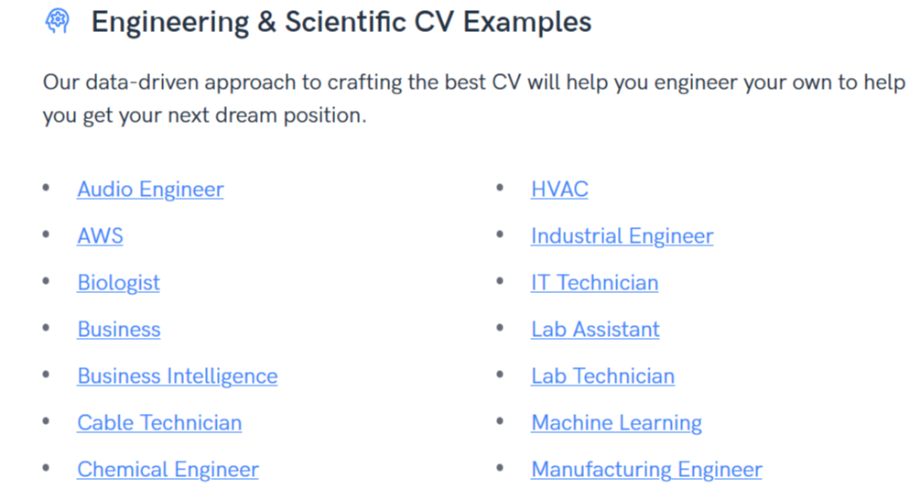

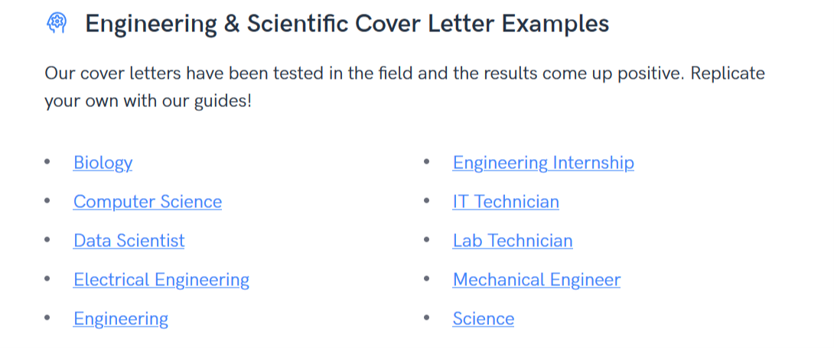

**(Personal information)**

**Mr. or Ms. First name** then **last name**

27, rue XXXXX

33000 Bordeaux, France

(Date of birth) 21/06/2001 –and/or 18 years old (This should not be included on a cv for an English or American company but may be asked for international mobility)

(Telephone) +33 (0) 562 ... ...

(Mobile) +33 (0) 645 … ...

(E-mail address) **….@...**

Valid driving licen**s**e, car owner / I have my own car *(this could also be included in the ‘additional info’ part*

*~~Single~~*~~,~~ *~~married~~* ~~(~~This should not be included on a cv for an English or American company)

***(Profile)***

**Second-year student looking for a work placement in (*field, ex:* renewable energies and environment) from January to April 2023**

*or*

**Applying for the position** *of Embedded Calibration Technician at Delmar Products, Lyon, France*

**Education *(to adapt, according to specialization, A levels etc)***

**From September 2021 to June 2024**: Currently attending a three-year University Bachelor of Technology in Applied Physics and Measurements Engineering, with a specialisation in Instrumentation Techniques ***or*** Materials Engineering and Physico-Chemical Controls ***or*** Environmental Measurements and Analyses (180 ECTS), at the University Institute of Technology (IUT), Bordeaux University, France.

*(pour le Bachelor international:)* Enrolled in the International Track with 30 % of scientific content taught in English.

*(pour les alternants:)* currently attending a three-year University Bachelor of Technology with a one-year block-release training.

Courses are attended in Applied Physics and Measurements Engineering, with a specialisation in Instrumentation Techniques ***or*** Materials Engineering and Physico-Chemical Controls ***or*** Environmental Measurements and Analyses (180 ECTS), at the University Institute of Technology (IUT), Bordeaux University, France, and work experience is acquired at (NAME OF COMPANY) for several months (equivalent to a year).

**June 2021:** Obtained a French general high-school diploma, equivalent to the A-levels in the UK, majoring in (ex: Sciences) with a specialisation in (ex: Chemistry and Physics) and … (ex: English European Section); Lycée XXXX, Ville, France.

**Skills *(categories to reorganize: too disconnected from experience?)***

**Techniques and know-how** /soft skills (savoir-faire*)*

*[with verbs]* able to set up a test bench on electronic devices…. applied to … , to choose the equipment of control and trials to check conformity with a technical specification, to define a measurement chain, to determine a measurement uncertainty, to follow procedures, to install and calibrate CO² sensors to control the quality of air …

*[with nouns]* Implementation of a chain of optical measurements, good command of the principles and implementation of spectroscopic and chromatographic analysis techniques. Study of chemical reactions, material characterization technique (electron microscopy, Xrays and thermogravimetry). Good command of characterization techniques of mechanical actions and deformation of solids subjected to force systems. Good command of environment monitoring and analysis.

**applied to the following domains (disciplines/modules studied)**

Thermodynamics, Optronics, Nuclear Physics (depending on target!)

**Computer skills**

Good command of Microsoft Office tools (Word, Excel and PowerPoint), C Language Programming

**Language skills**

French: Mother tongue

English: Good working knowledge, technical reading and writing, everyday life and technical vocabulary, conversation practice, etc. Mention the European track (from A1 to C2* in speaking and from A1 to C2 in understanding?)

Spanish: Basic working knowledge, conversation (A1 in speaking and A2 in understanding); good grounding…

* according to the Common European Framework of References for Languages (see video on <http://www.cambridgeenglish.org/exams-and-tests/cefr/> )

Good communication skills: developed ability to produce reports and oral presentations adapted to different audiences; creation and regular updating of a blog for my local volleyball club, etc.

**Education-related experience (or Vocational training)**

**2nd year tutored projects (Saé ptut S3) from September 2022 to December 2022:** *… what is yours?*

**1st year tutored projects in 2021-2022:** *what did you do? what was your measurement campaign about? what was your role? what kind of findings could you present?*

**Other employment**

**July 2022:** Urban cleaning services worker (Cleaning Sector, Environment, Planning and Cleaning Services) - Bordeaux City Hall, FRANCE: Maintained clean footpaths in the South West sector of the Bordeaux city center. This position required excellent self-management and time keeping discipline as each employee worked independently and had to perform tasks in a limited time period in the early morning so as not to disrupt access to local businesses**.**

**Personal interests (or) qualifications (or) personal achievements *= titre à choisir***

**Interests:** Sustainable energy, robotics

**Music:** Piano for 12 years, guitar for 5 years

**Travel:** 2-week stay in California, USA (August 2019), Widespread travel through Europe (Greece, Germany, England, Italy, Portugal) and French West Indies

**Sports:** Football, Basketball – everyday practice with local club; Official Badminton referee in the Department Club of ….. (Ville, France),

**College:** President/treasurer of the Applied Physics and Measurement Engineering students’ association. Organization of activities for students, selling the devices for practical works in chemistry lab.

**Qualifications/ certificates:**

First Aid qualification / Qualification in First Aid / First Aid Certificate (Brevet de Secourisme)

Lifesaving training, lifeguard certification

Qualified youth leader (BAFA)

Pilot’s license (Brevet de pilote)

Aeronautics Initiation certificate

Climbing qualification