Practical work of April , 2023

Discovery soft tool for avionics and radionavigation
Works only on PC with Windows, but not on mac/apple OS or tablet !

Prerequisites
Step 1: Please verify first that a version of LabVIEW later than 2018 is installed on the running computer or please download and install the Runtime 2018 SP1 32 bits from National Instruments website: https://www.ni.com/fr-fr/support/downloads/software-products/download.labview-runtime.html#329458
This download requires a user account on ni.com

Check and specify the configuration of your PC below:
LabVIEW installed on your computer | LabVIEW not installed | Runtime required
Version : |  | Y or N ?

Step 2: Download (“Téléchargement” in French) the ZIP file named “Avionics_RDNAV_evering_0205_DM0074.zip” (Up-to-date version: May 2th, 2023) using the link below and extract it into a folder (UNZIP)
Step 3: From this unzipped folder, execute the application “Avionics_RDNAV_evering_020523.exe”.
A "Windows" security window will probably open :
- then click on "additional information" and then on "execute anyway"...
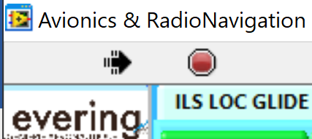 If the arrow is black, then everything is OK, the application is running…
If the arrow is WHITE click on the white arrow to use it

Optional step 4: If the arrow is black and crossed out,

then you probably forgot to unzip the downloaded file OR you will probably have to download the additional program from the following link:
https://www.ni.com/en-vn/support/downloads/drivers/download.ni-daqmx.html#382067

Check your configuration and specify:
- “Avionics_RDNAV_evering_020523_DM0074.zip” is download ?
- Is the Zip file unzipped (right mouse button and unzip) Y/N?
Specify the decompression directory on your computer:
- Run "avionics_RDNAV_evering020523.exe" Y/N?
- Is the arrow White, Black or Broken Black?
- If Broken Black, then load the driver at the link indicated in step 4. Y/N?
Name and location for lab report :

Lab report
- A pdf file has to be uploaded at the end of the lab inside the Moodle session or mail
- Commented screenshots of the different tasks welcome
- Name of your file for lab report: Lpo_yourName_020523.pdf

Denis MICHAUD : denis.michaud@u-bordeaux.fr

Associate lecturer at evering institute, University of Bordeaux, in aeronautics, avionics and electrical systems

Presentation of the main tabs

Course 1 : Units in aeronautic, Data bus, dB

Unit conversion to aeronautics : handling the tool.
Please select the Manometric system tab > SIMULATOR Atmosphere ISA tab
Q01. Convert T₁ = 55°C and T₂ = 12°C into Fahrenheit and Kelvin.
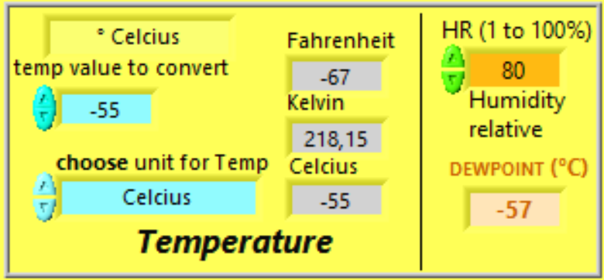
Figure 1: Done with teacher's help
Q02a. Convert T₃ = 96°F and T₄ = 0°F into Celsius and Kelvin.

Q02b The temperature near the ground is +8°C and the dew point temperature is +6°C.
The relative humidity RH is % ?

Q03. Convert D₁ = 52 NM and D₂ = 4 NM into km and ft.

Q04. Convert V₁ = 56 km/h into FPM, m/s, knots.

Q05. Convert V₂ = 650 KT into km/h, FPM, m/s, Beaufort unit.

Latitude & longitude coordinates system
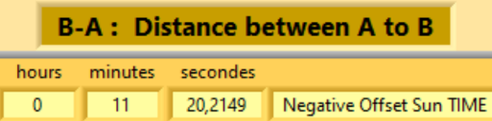
Please select the latitude/Longitude tab > Simulator Coordinates Latitude & Longitude tab

Q6. Compute the distance in NM and km and the time difference of the sunrise between:
Airports | NM | km | Time diff
Brest and Strasbourg (both in France)
Mérignac (France) and Cincinnati (US)
Hanoi (Vietnam) and Barcelona (Spain)
Hanoi and Ho-Chi-Minh-Ville (both in Vietnam)
Tokyo and Sydney
Tokyo and San Francisco
0°N – 25°E and Merignac airport
5.33°S – 106.667°E and Toulouse-Blagnac (France)

Signals: voltage and power units
Please select the radio VHF tab > Level dB dBm tab
Q7.a. Convert 1W into dBW and into dBm. Give the relation between dBW and dBm

Q7.b. Convert 10 mW into dBW and into dBm. What is the associated voltage with Z = 50Ω?

Q7.c. Convert 10 mW into dBW and into dBm. What is the associated voltage with Z = 377Ω?

Q7.d. Convert 20 mW into dBW and into dBm. What is the associated voltage with Z = 600Ω?

Q7.e. Convert 2.2V into dBV and mW and into dBm when Z = 600Ω.

Q8. Complete the table below, for the sum and difference of two powers among the 5 powers from P1 to P5 proposed (principle of conservation of energy)?
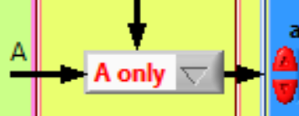
 | P1 | P2 | P3 | P4 | P5 | P1+P2 | P1-P2 | P3+P4 | P3-P4 | P1+P3
(dBm) | +10 dBm | +5 dBm | 0 dBm |  | -5 dBm
(mW) |  |  |  | 1 mW

Q9. Assuming that one uses the computation of P2-P4 (with the previous values), what will be the result?

Q10. The tracking sensitivity is the minimum power level at which a receiver can receive and maintain a connection with a satellite or constellation of satellites and is about -160 dBm. Convert back into W and mW.

ARINC 429 Databus
Please select the DATABUS ARINC 429 tab > Generalities ARINC 429 tab
Q11. How many bits are there to code a 429 ARINC word?

Q12. What are the characteristics of the label part (coding, number of bits…)

Q13. Is the overall parity odd or even?

Q14. What are the communication rates within ARINC429 standards?

Please select the DATABUS ARINC 429 tab > Simulator word Calculation 32 bits for ARINC 429 tab
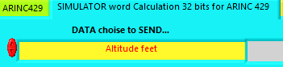
and then SELECT altitude feet

Q15. Which binary word is transmitted when the altitude is 6000 ft. With which label?

Q16. Which data encoding type is used for the altitude data?

Q17. Which binary word is transmitted when the altitude is 6300 ft. With which label in octal an binary?

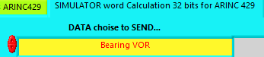
then SELECT Bearing VOR
Q18. Which binary and hexadecimal words represent the bearing received
from the VOR station with QDR = 90° ?
With which label?

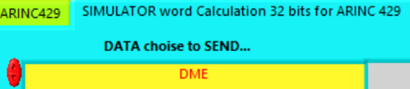
then SELECT DME ( 2 solutions )
Q19. Which binary word is transmitted for a DME distance equal to 125.8 NM? With which label? Check the parity bit. Is the encoding type in BCD or BNR format for DME distance information?

Please select the Manometric system tab > SIMULATOR Atmosphere ISA tab

Course 2 : Manometric, RDNAV, radio ,DME, XPDR

Aerology

Q20.a. Compute the True Air Speed, Mach number and density when IAS₃ = 350 KT at FL380.

Q20.b. Compute the True Air Speed, Mach number and density when IAS₄ = 350 KT at FL150.

Q20.c. Compute the True Air Speed, Mach number and density when IAS₅ = 350 KT at FL050.

Q21.a. Convert P₁ = 1040 hPa, P₂ = 1013 hPa and P₃ = 990 hPa into psi, bar, MPa, inHg and N/m².

Q21.b. Convert P₄ = 30.25 inHg, P₅ = 28.14 inHg into psi and mbar.

You can either select the Manometric system tab > Machmeter tab
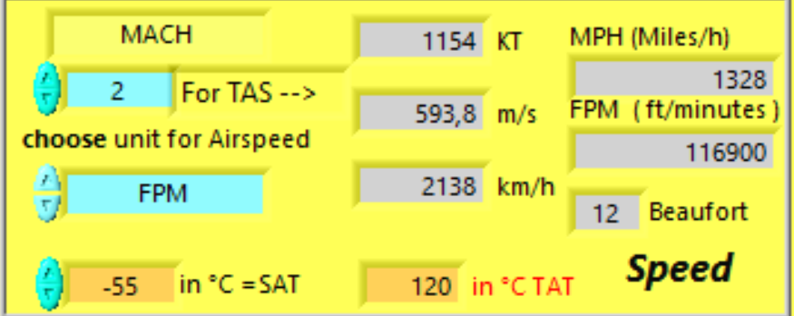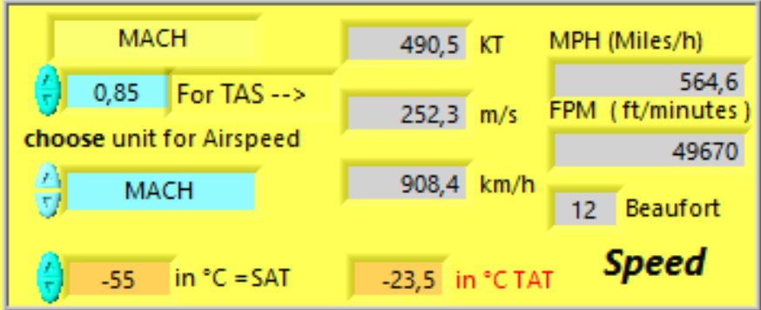
Q22.a. Assuming an A380 aircraft flying at a IAS = 270 KT near FL350, QNH 1013, what is the Mach number and the temperature SAT when TAT measured is equal to –20°C? Compare to the temperature given by ISA modeling, quoted T_{ISA}.
Mach Number =
SAT =
ISA +

Q22.b. Assuming a Cessna aircraft flying at a speed of 200 km/h near FL100, QNH 1013, what is the SAT when TAT measured is equal to -8°C? Compare to the temperature given by ISA modeling, quoted T_{ISA}.
Mach Number =
SAT =
ISA +/-
?
Q22.c. Assuming a Concorde aircraft flying at Mach 2 with an altitude of 16000 m, what is the TAT measured? Same question at Mach 2.2 and Mach 0.85. Compare to the temperature outside the aircraft.

Q23. What are the composition and the percentage of the two main gas components of the atmosphere?

Airport data
Please select the Manometric system tab > Chart & weather tab > Vietnam approach chart >
Click on USTH logo for more information
Q24. For the Hanoi and Ho-Chi-Minh-Ville airports, identify:
 | Hanoi | Ho-Chi-Minh
- Runway numbers and airport QFU

- ILS frequencies and Morse-code identifiers

ATIS and VOR frequencies

ICAO and IATA code

Magnetic declination

Pressure difference between QNH and QFE

Please select the latitude/Longitude tab > LFBD
Q25. For the Merignac airport, identify:
- Runway numbers and airport QFU
- ILS frequencies and Morse-code identifiers
- Magnetic declination
- Pressure difference between QNH and QFE

DME
Please select the DME & ATC tab > SIMULATOR XPDR – DME tab > Simulator DME tab
You can also select the DME & ATC tab > principle DME tab ….
Q26. What are the DME frequencies associated to the VOR at frequency 113.75 MHz?
Q27a. What is the jitter for DME?

Q27b. What is its frequency band of DME?

Q28. What is the frequency gap between transmission and reception signals?

Q29. What is the DME frequencies associated to the frequency 114.95 MHz? Is it a VOR or ILS frequency?

Q30a. Tmeasured = 1.34 ms of time taken for DME range has been measured in X mode. What is the corresponding distance shown by DME?
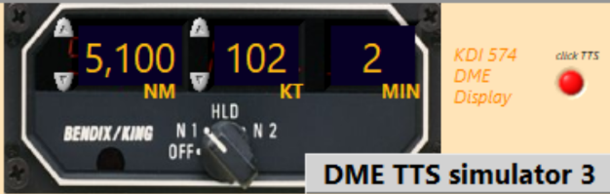

Please use DME TTS simulator 3
Q30b. What is the Time To Station TTS for a GroundSpeed = 200 KT and DME = 12 NM

XPDR transponder
Please select the DME & ATC tab > SIMULATOR XPDR - DME tab > XPDR ATCRBS tab
Or Please select the DME & ATC tab > Virtual Alticoder tab > FL tab or SQUAWK tab

Q31. How many bits are needed to code the transmitted altitude using C mode?

Q32. What is the altitude resolution (in ft)?

Q33. With how many bits is coded the SQUAWK identification code transmitted using A mode?

Virtual alticoder
Please select the DME & ATC tab > SIMULATOR XPDR -DME tab > Virtual Alticoder tab
Q34. What is the coding name used by the transponder alticoder for altitude transmission using C code? Is it ASCII, O’BRIEN, OCTAL, GILHAM, binary?
Q35. What is the pressure setting of the alticoder for transponder?

Q36. What does ATCRBS stand for?
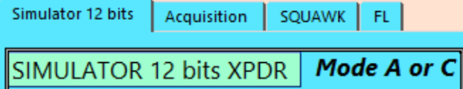
Please select the DME & ATC tab > Virtual Alticoder tab > clic on
- Select SQUAWK or FL tab

Q37. What are the SQUAWK codes equivalent to the following altitude:
12300ft? SQUAWK =
1200ft?
FL195?
FL250?
What are the equivalent altitude and FL for de SQUAWK code :
For SQUAWK = 7000 ? altitude Z = ft ? FL =
For SQUAWK = 4200 ? altitude Z = ft ? FL =

Course 3 : Maintenance Troubleshooting, ACARS, avionics

Avionics
Please select the ILS LOC GLIDE tab > ILS PRINCIPLE tab
Or Please select the Maintenance tab > Documentation tab> Arinc tab

Q38. What is the dedicated ARINC standard and ATA chapter for the ILS?

Please select the Avionics tab > black box
Q39. Which system stores the flight data? (useful in case of an accident) . and ATA chapter ?

Please select the Avionics tab > Cockpit tab
Q40. Inside the cockpit, how many screens, DU Display Unit, are there in the Airbus A320? Boeing 777 ?

Maintenance Please select the Maintenance tab > “ACARS” tab

Q41a. What is the role of the ACARS system?
Q41b. Which associated ARINC standard and ATA chapter are required for ACARS?

Q41c. What is the ATA chapter for the “black boxes”? Please select the Avionics tab > Black Box tab

Airspeed Please select the Manometric system tab > SIMULATOR Atmosphere ISA tab
Or Please select the Manometric system tab > Airspeed tab > Simulator Airspeed tab

Q42a. Compare the different AirSpeed CAS EAS TAS GS for IAS = 250 KT at Z = 36 000 ft 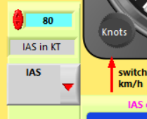
Mach number = ?
Impact Pressure
Total Pressure ?

Q42b. Compare the different AirSpeed CAS IAS TAS GS for EAS = 480 KT at Z = 42 000 ft 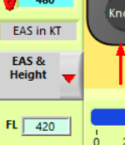
Mach number = ?
Impact Pressure
Total Pressure ?

System EWIS Please select the Maintenance tab > EWIS tab

Q42c. Which EWIS is relevant for avionics?
According to AWG specifications, > EWIS & CABLE & Wire GAUGE & AWG tab
What is the diameter of a cable with AWG10 in mm?
What is the Max Current carrying capacity in ampere (AWG10)?
Is the cross-section of an AWG3 cable smaller or larger than the cross-section of an AWG10 cable?
Is an AWG3 cable heavier or lighter than an AWG10 cable of the same length?

Course 4: RDNAV, VOR, ILS, ADF, angle for navigation

Instrument Landing System
Please select the ILS LOC GLIDE tab > ILS PRINCIPLE tab > ILS principles tab or LOC tab or GLIDE tabs….
Please select the ILS LOC GLIDE tab > SIMU LOCALIZER or SIMU GLIDE tab

Q43a. What are the carrier frequency bands for all ILS Localizer and Glide path?
Carrier frequency LOC :
Carrier frequency GLIDE :

Q43b. What are the signal bandwidths for each channels for the Loc and Glide carriers?
Bandwidth LOC :
Bandwidth GLIDE :

Q43c. Which frequency is preponderant if the aircraft is too above and too RIGHT : 90Hz or 150Hz?
What is the deviation bar position ?

Preponderant frequency for UP:
Preponderant frequency for Right :
Horizontal deviation bar :
Vertical deviation bar :
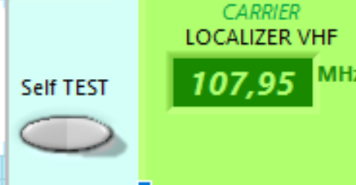
Please select the ILS LOC GLIDE tab > SIMU LOCALIZER
Q43d. Test the “Self test” mode (grey button on your left).
Observe the harmonic frequencies… oDD / even ?

What shows the indicator and the modulating signal spectrum?

In test mode, Aircraft is too UP or Down ?

In test mode, Aircraft is too LEFT or RIGHT ?

Q44.a. What is the Glide and DME frequencies for the ILS on the 23rd runway in Merignac airport?
Please select the latitude/longitude tab > LFBD tab > red selector

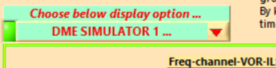
Frequency LOC for RWY 23 on LFBD = MHz

Please select the DME & ATC tab > Simulator DME tab & DME SIMULATOR 1 selector ->
Frequency GLIDE for RWY 23 on LFBD = MHz
Frequency DME interrogation for RWY 23 on LFBD = GHz
Frequency DME reply for RWY 23 on LFBD = GHz

Q44.b. What is the Glide and DME frequencies associated with the Localizer frequency 109.35 MHz?
Frequency GLIDE for paired 109.35 LOC = MHz
Frequency DME interrogation for paired 109.35 LOC = GHz
Frequency DME reply for paired 109.35 LOC = GHz

Q44.c. What is the Glide and DME frequencies associated with the Localizer frequency 108.15 MHz?
Frequency GLIDE for paired 108.15 LOC = MHz
Frequency DME interrogation for paired 108.15 LOC = GHz
Frequency DME reply for paired 108.15 LOC = GHz

Q44.d. What is the values:
If DME = 25 NM and slope angle = 6%: What is the values for Time taken, Ground distance and Height ?
If Height = 12 000 ft and slope angle = 10%: What is the values for Time taken, Ground distance and Slant range DME ?

VOR understanding: the 21 aircrafts situation
Please select the VOR tab > Simulator VOR tab
- Click on the left button “exercices 21 aircrafts” 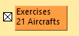
- The following window pops up
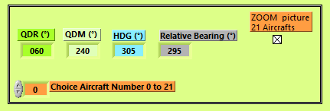
- Select the button Zoom picture to resize the picture with the 21 aircrafts 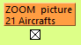
- Enter the number of the chosen aircraft for your study 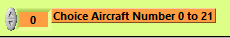
- The software will set the values according to chosen aircraft position regarding to the VOR station.
- You can then set the desired OBS
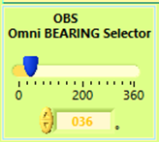
- Instruments will then indicate from/To and left/right for the selected OBS.
Q46. Choose 3 aircrafts and set the magnetic declination to 13°W. 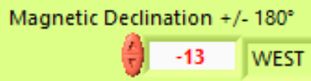
What are the QDM, QDR, relative bearing and heading for the aircrafts?
Aircraft N° | QDM | QDR | Relative bearing

Q47. For the chosen aircrafts and for the 2nd and 14th aircraft, indicate if they are from/to/ or neither between from and to, and if vertical deviation bar is left/right/align according to the OBS selected values.
Selected OBS | 090° | 030° | 305° | 035°
Aircraft n°1 | Right : From | Left : From | Left : TO | Left : From

Aircraft n°

Aircraft n°

Aircraft n°
Aircraft n° 14 |  |  | Align : TO
Aircraft n° 2 |  |  | Left, Neither From nor To | Align : From

Conclusion
Please quote remarks and improving methods or suggestions that can be used in this lab.

